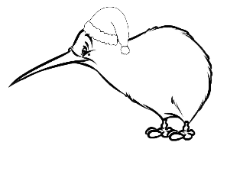
Christmas in New Zealand

Word Match

NZ slang Meaning Japanese
heaps | relatives / family | 日焼け止め
nan | Barbeque (BBQ) | 一、二、三、四
ice block | sun screen | バーベキュー
barbie | many / a lot | 親族
pav | one, two, three, four | パブロワ
rellies | ice lolly | たくさん
sun block | Grandma | お婆さん
Tahi, rua, toru, wha | pavlova | アイスバー
Tongue Twisters

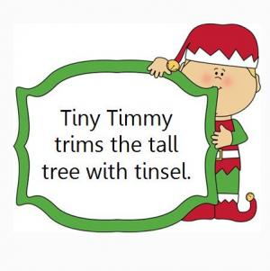
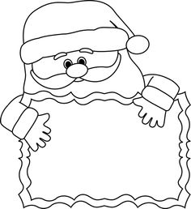
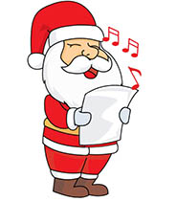
Santa’s sleigh slides on slick snow
Seven Santas sang silly songs

